Cairo University  
Faculty of Computers and Information



**CS251**

**Software Engineering I**

Social Network

Software Design

December,2019

Contents

Team 3

Document Purpose and Audience 3

System Models 4

I. System Decomposition 4

II. Class diagrams 5

III. Sequence diagrams 7

Class - Sequence Usage Table 12

Ownership Report 13

# Team

|  |  |  |  |
| --- | --- | --- | --- |
| **ID** | **Name** | **Email** | **Mobile** |
| 20170098 | Khaled Ezzat El-Hadary | khaledelhadary@outlook.com | 01276016539 |
| 20170093 | Hussien Ashraf Feteiha | hussienashraf99@gmail.com | 01016395068 |
| 20170085 | Hatem Mamdouh Saied | matrix.leader@yahoo.com | 01016192209 |
| 20170148 | Abdelrahman Mohamed Ahmed | rahmana_mohamed@yahoo.com | 01123179765 |

# Document Purpose and Audience

**This document will define the design of social network API. It contains specific information about expected input, output, classes and functions. The interaction between the classes to meet the desired requirements are outlined in detailed figures at the end of the document. Therefore, the intended reader groups for this software requirement specification are project managers and developers interested in making a social network API.**

# System Models

## I. System Decomposition

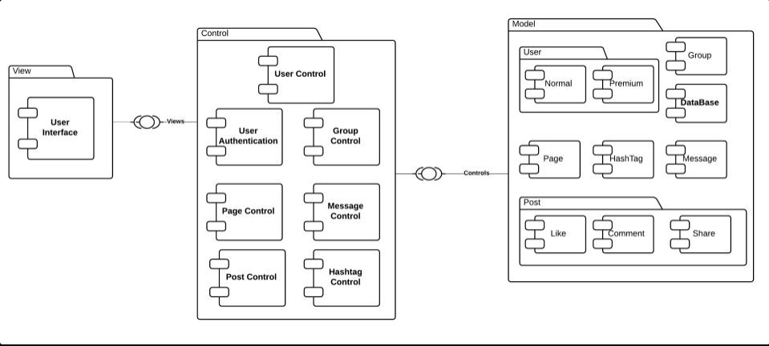

## 

## II. Class diagrams

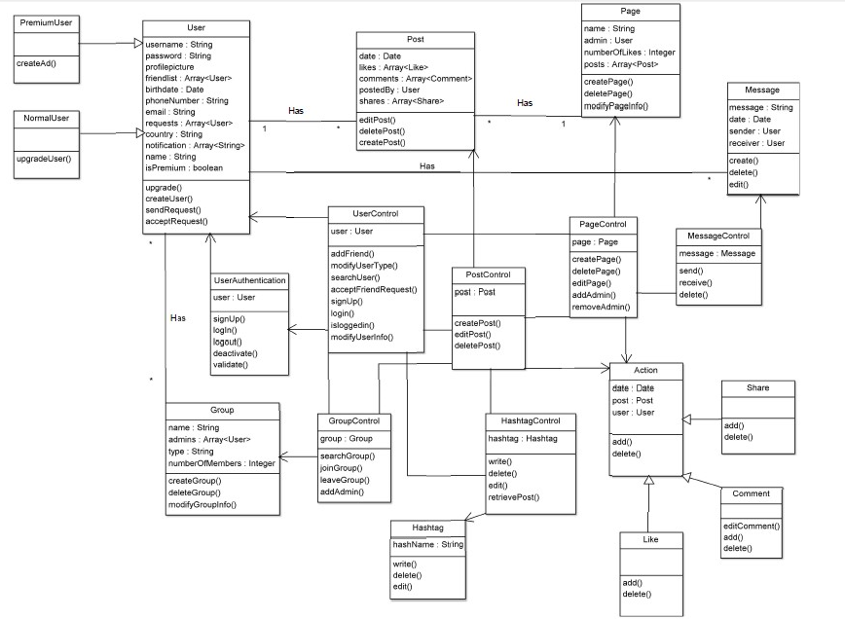

| **Class ID** | **Class Name** | **Subsystem Name** | **Description & Responsibility** |
| --- | --- | --- | --- |
| 1 | User | Model | Has all the user’s data such as username and email. It is an entity class. |
| 2 | Normal | User | It is a child from user class where it has just the basic functions of the user but doesn’t have premium privileges such as creating ads. |
| 3 | Premium | User | It is a child from user class where it has just the basic functions of the user and has premium privileges such as creating ads. |
| 4 | Hashtags | Model | Holds all the data needed for the hashtag. It is an entity class. |
| 5 | Page | Model | Holds all the data needed for the pages. It is an entity class. |
| 6 | Post | Model | Holds all the data needed for the post. It is an entity class. |
| 7 | Message | Model | Holds all the data needed for the message such as sent date and sender and receiver. It is an entity class. |
| 8 | Like | Post | Holds all the data needed of the likes for the post such as the person who liked or total number of likes. |
| 9 | Comment | Post | Holds all the data needed of the comments for the post such as the person who commented or total number of comments. |
| 10 | Share | Post | Holds all the data needed of the shares for the post such as the person who shared or total number of shares. |
| 11 | User Control | Control | Responsible for controlling all activities that could be made by the users. |
| 12 | User Authentication | Control | Responsible for controlling the authorization actions such as login and signing up. |
| 13 | Group Control | Control | Responsible for controlling all activities that could be made in a group. |
| 14 | Message Control | Control | Responsible for sending and receiving messages. |
| 15 | Hashtag Control | Control | Responsible for controlling all hashtag activities and retrieving posts with hashtag included in it. |
| 16 | Page Control | Control | Responsible for controlling all activities that could be made in a page. |
| 17 | Post Control | Control | Responsible for controlling all activities that could be made in the post. |
| 18 | User Interface | View | Responsible for allowing access to the system. |

## 

## III. Sequence diagrams

**3.1 Sign up SD :-** 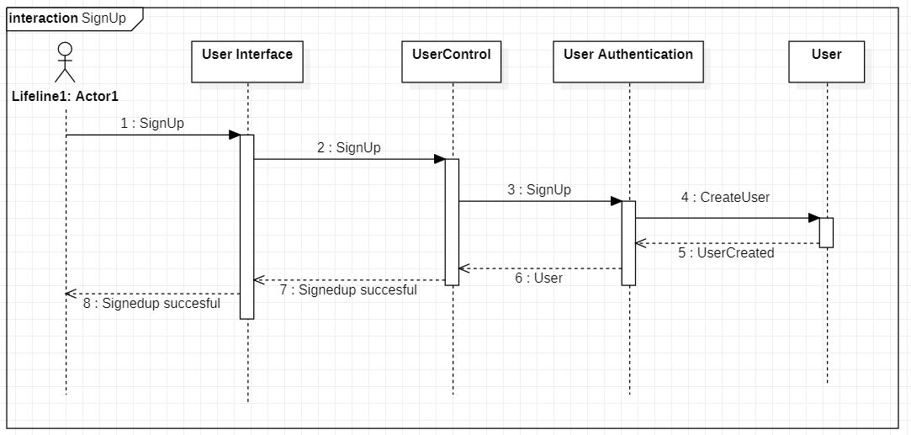

**3.2 Send message SD :-**

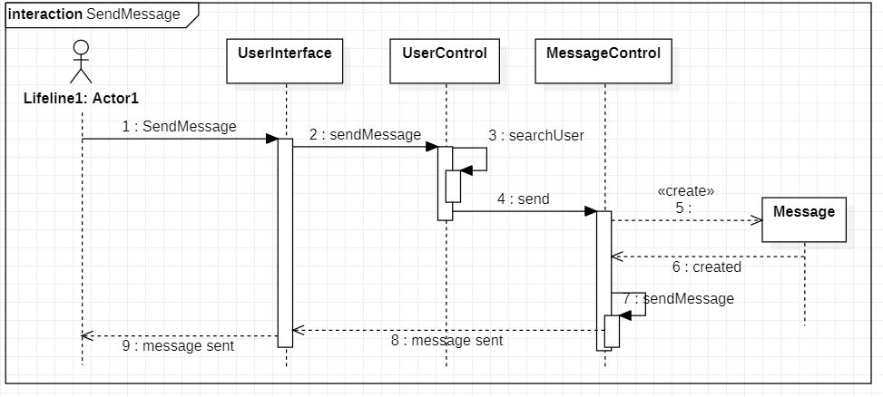

**3.3 Change User Type SD :-**

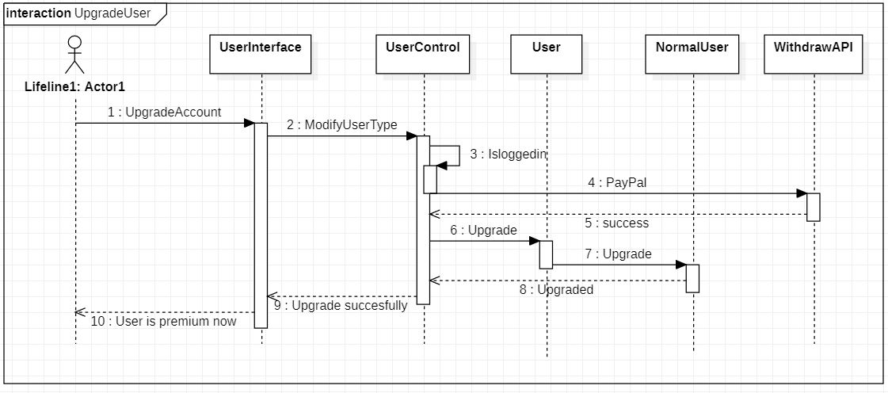

**3.4 Change Profile Picture SD :-**

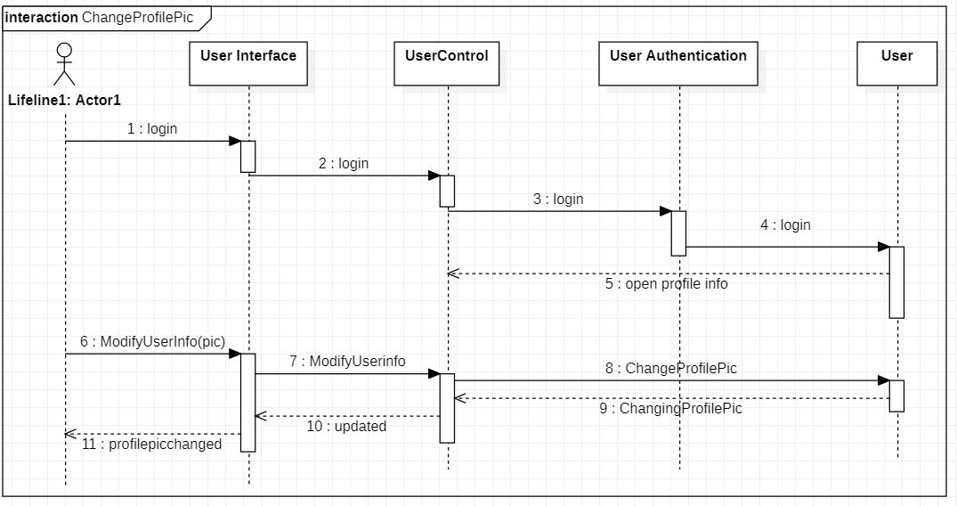**3.5 Create Page SD :-**

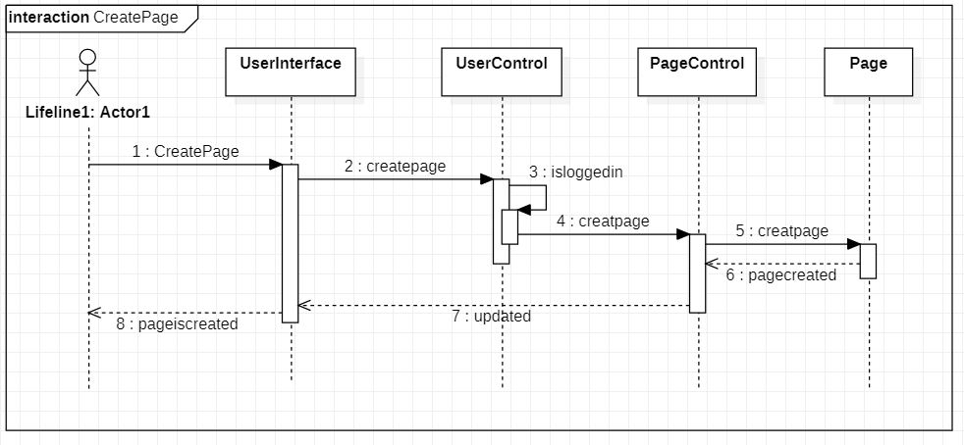

**3.6 Adding members to group SD :-**

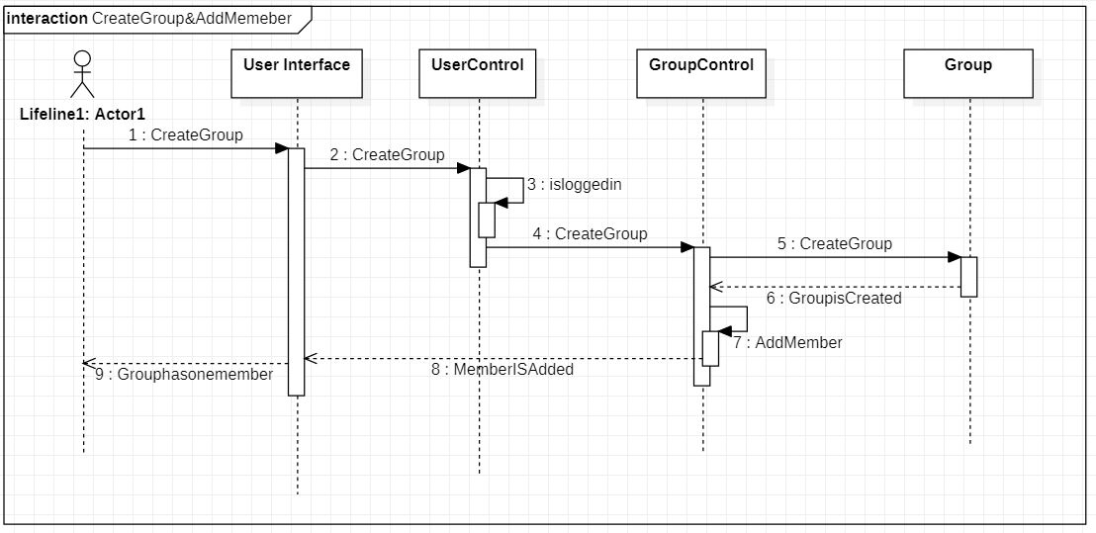

**3.7 Join Group SD:-**

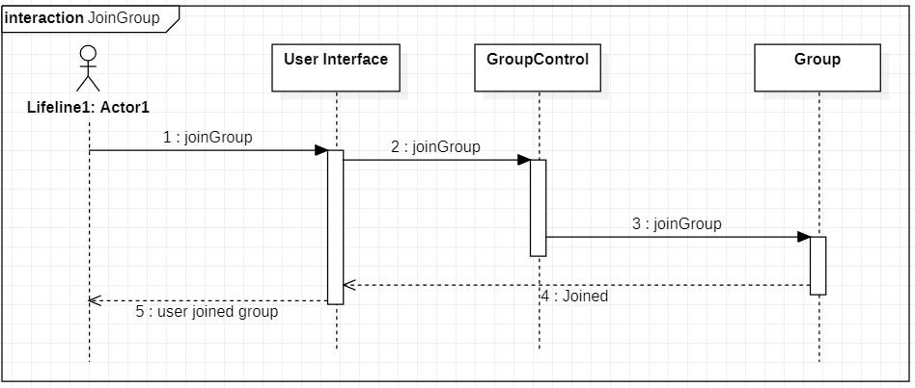

**3.8 Search Hash tag SD :-**

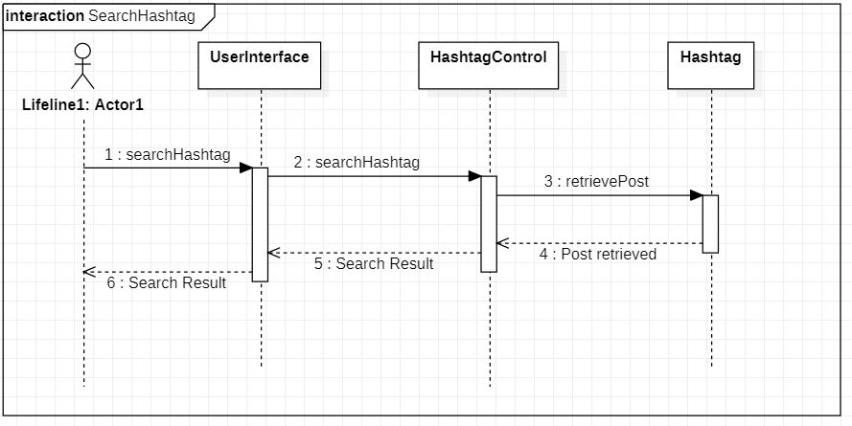

**3.9 Sign Out SD :-**

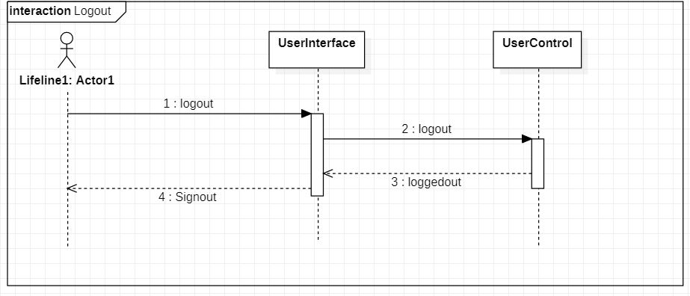

### 

### Class - Sequence Usage Table

| **Class Name** | **Sequence Diagrams** | **Overall used methods** |
| --- | --- | --- |
| User Interface | 3.1 , 3.2 , 3.3 , 3.4 , 3.5 , 3.6 , 3.7 , 3.8 , 3.9 | signUp , createUser , sendMessage , searchUser , send , upgradAccount , upgrade, modifyUserType , login , changeProfilePicture ,modifyUserInfo, createPage , createGroup , joinGroup , searchHashtag , retrievePost , logout |
| User | 3.1 , 3.3 , 3.4 | signUp , createUser , upgradAccount , upgrade , modifyUserType , login , changeProfilePicture , modifyUserInfo |
| Normal User | 3.3 | upgradAccount , upgrade, modifyUserType |
| Premium User |  |  |
| User Authentication | 3.1 , 3.4 | signUp , createUser , login , changeProfilePicture , modifyUserInfo |
| User Control | 3.1 , 3.2 , 3.3 , 3.4 , 3.5 , 3.6 , 3.9 | signUp , createUser , sendMessage , searchUser, upgradAccount , upgrade, modifyUserType , login , changeProfilePicture ,modifyUserInfo , createPage , createGroup , logout |
| Page | 3.5 | createPage |
| Page Control | 3.5 | createPage |
| Group | 3.6 , 3.7 | createGroup,joinGroup |
| Group Control | 3.6 , 3.7 | createGroup,joinGroup |
| Hashtag | 3.8 | searchHashtag , retrievePost |
| Hashtag Control | 3.8 | searchHashtag , retrievePost |
| Post | --- | --- |
| Post Control | --- | --- |
| Action | --- | --- |
| Like | --- | --- |
| Share | --- | --- |
| Comment | --- | --- |
| Message | 3.2 | sendMessage , searchUser , send |
| Message Control | 3.2 | sendMessage , searchUser , send |

# Ownership Report

|  |  |
| --- | --- |
| **Item** | **Owners** |
| System Decomposition | All |
| Class Diagram | All |
| Sequence Diagram 3.1 | **Hussien Ashraf Fetiha** |
| Sequence Diagram 3.2 | **Hatem Mamdoh Said** |
| Sequence Diagram 3.3 | **Hussien Ashraf Fetiha** |
| Sequence Diagram 3.4 | **Khaled Ezzat Ahmed** |
| Sequence Diagram 3.5 | **Khaled Ezzat Ahmed** |
| Sequence Diagram 3.6 | **Abdelrahman Elmehrizy** |
| Sequence Diagram 3.7 | **Hussien Ashraf Fetiha** |
| Sequence Diagram 3.8 | **Abdelrahman Mehrizy** |
| Sequence Diagram 3.9 | **Hatem Mamdoh Said** |